EXPERIMENT 1
CODING
a <- c(10, 20, 30, 40)
print(a)
print(class(a))

b <- c("Anu", "Bala", "Divya")
print(b)
print(class(b))

c <- c(TRUE, FALSE, TRUE)
print(c)
print(class(c))
OUTPUT
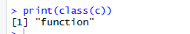

EXPERIMENT 2
CODING
a <- matrix(1:20, nrow=5, ncol=4)
print(a)
b <- matrix(1:9, nrow=3, ncol=3)
print(b)
c <- matrix(1:4, nrow=2, ncol=2)
print(c)

OUTPUT
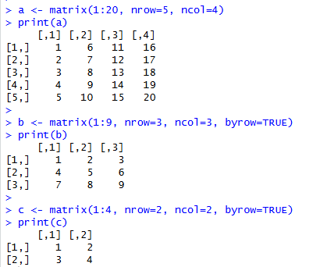

EXPERIMENT 3
CODING
a <- 1:24
arr <- array(a, dim=c(2,3,4))
print(arr)
OUTPUT
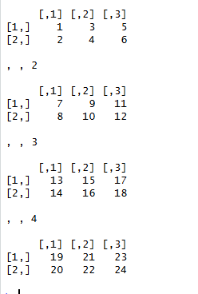

EXPERIMENT 4
CODING
a <- 1:8
b <- array(a, dim=c(2,2,2))
print(b)
print(b[2,1,2])
OUTPUT
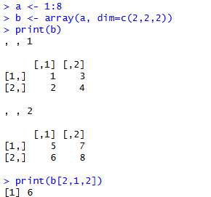

EXPERIMENT 5
CODING
a <- c("Short", "Medium", "Tall", "Medium", "Tall", "Short")
b <- factor(a)
print(b)

set.seed(10)
c <- sample(LETTERS[1:5], 8, replace=TRUE)
d <- factor(c)
print(d)
output :
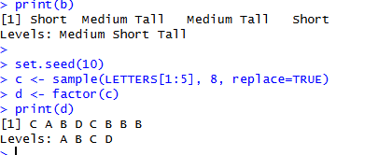

EXPERIMENT 6
CODING
a <- c(1,2,3,4)
b <- matrix(1:6, nrow=2, ncol=3)
c <- function(x) x^2

mylist <- list(Vector=a, Matrix=b, Function=c)
print(mylist)
OUTPUT
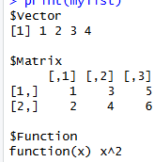

EXPERIMENT 7
CODING
n <- 12
factors <- c()

for(i in 1:n) {
if(n %% i == 0) {
factors <- c(factors, i)
}
}
print(factors)

set.seed(123)
print(sample(-50:50, 10, replace=TRUE))

for(i in 1:100) {
if(i %% 15 == 0) {
print("FizzBuzz")
} else if(i %% 3 == 0) {
print("Fizz")
} else if(i %% 5 == 0) {
print("Buzz")
} else {
print(i)
}
}

OUTPUT
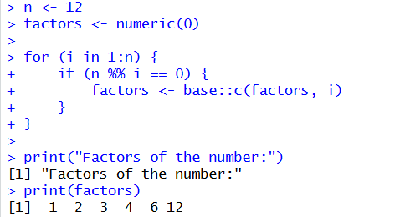

EXPERIMENT 8
CODING
set.seed(123)
x <- rnorm(100)
y <- table(round(x))
print(as.data.frame(y))
OUTPUT
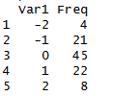

EXPERIMENT 9
CODING
plot(1, type="n",
xlim=c(0,10),
ylim=c(0,100),
xlab="X axis",
ylab="Y axis")
OUTPUT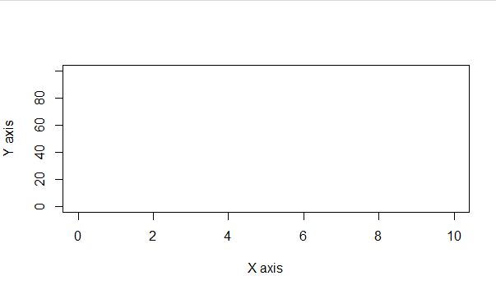

EXPERIMENT 10
CODING
x <- data.frame(
name=c("Anu","Bala","Charan","Divya","Esha"),
score=c(85,62,90,75,88),
attempts=c(1,3,2,2,1),
qualify=c("yes","no","yes","no","yes")
)

x <- rbind(x, data.frame(
name="Farhan", score=70, attempts=3, qualify="no"
))

x$grade <- c("A","C","A+","B","A","B")
x <- x[order(-x$score),]

print(x)
write.csv(x, "x.csv", row.names=FALSE)OUTPUT
